Climbing the Leaderboard editorial
Problem link: https://www.hackerrank.com/challenges/climbing-the-leaderboard/editorial

First, let’s build the leader board.
Example:
for the list of score below:

scores: | 100 | 100 | 50 | 40 | 40 | 20 | 10
 | 0 | 1 | 2 | 3 | 4 | 5 | 6

The leader board will be:

score_rank: | 100 | 50 | 40 | 20 | 10
 | 0 | 1 | 2 | 3 | 4

let’s take this scores for Alice:

alice: | 5 | 25 | 50 | 120
 | 0 | 1 | 2 | 3

The process will be:
  score_rank: | 100 | 50 | 40 | 20 | 10
   | 0 | 1 | 2 | 3 | 4
  score_rank: | 100 | 50 | 40 | 20 | 10 | 5
   | 0 | 1 | 2 | 3 | 4 | 5
  score_rank: | 100 | 50 | 40 | 20 | 10
   | 0 | 1 | 2 | 3 | 4
  score_rank: | 100 | 50 | 40 | 25 | 20 | 10
   | 0 | 1 | 2 | 3 | 4 | 5
  score_rank: | 100 | 50 | 40 | 20 | 10
   | 0 | 1 | 2 | 3 | 4
  score_rank: | 100 | 50 | 50 | 40 | 20 | 10
   | 0 | 1 | 2 | 3 | 4 | 5
  score_rank: | 100 | 50 | 40 | 20 | 10
   | 0 | 1 | 2 | 3 | 4
  score_rank: | 120 | 100 | 50 | 40 | 20 | 10
   | 0 | 1 | 2 | 3 | 4 | 5

As you see, for each Alice’s score, we lool for the last insertion position in the sorted by descending order array.

is the size of the Alice’s score list
is the size of the rank list

O(a x r) approach
For each Alice's score, compute the new score by pairwise comparisons.
We gonna use an algorithm similar to the insertion sort.
let’s take an example:
Scores for other players:
scores: | 100 | 100 | 50 | 40 | 40 | 20 | 10
 | 0 | 1 | 2 | 3 | 4 | 5 | 6

Scores of Alice:
alice: | 5 | 25 | 50 | 120
 | 0 | 1 | 2 | 3

The initial rank:

score_rank: | 100 | 50 | 40 | 20 | 10
 | 0 | 1 | 2 | 3 | 4

In the code, we will not really insert the score in the array, we gonna just compute the rank and add it to the array.
For Alice’s score , it will be inserted at the 6th position (index 5):

score_rank: | 100 | 50 | 40 | 20 | 10 | 5
 | 0 | 1 | 2 | 3 | 4 | 5

result: | 6
 | 0

For Alice’s score , it will be inserted at the 4th position (index 3):

score_rank: | 100 | 50 | 40 | 25 | 20 | 10
 | 0 | 1 | 2 | 3 | 4 | 5

result: | 6 | 4
 | 0 | 1

For Alice’s score , it exists (no need to insert) at the 2nd position (index 1):

score_rank: | 100 | 50 | 40 | 20 | 10
 | 0 | 1 | 2 | 3 | 4

result: | 6 | 4 | 2
 | 0 | 1 | 2

For Alice’s score , it will be inserted at the 1st position (index 0):

score_rank: | 120 | 100 | 50 | 40 | 20 | 10
 | 0 | 1 | 2 | 3 | 4 | 5

result: | 6 | 4 | 2 | 1
 | 0 | 1 | 2 | 3

Whole c++ code:
/*
Terminated due to timeout
O(alice_count x rank_list_size) -> quadratic
*/

#include <bits/stdc++.h>

using namespace std;

vector<int> build_rank(vector<int> scores){
vector<int> score_rank;
int scores_size = scores.size();
for (int i = 0 ; i < scores_size - 1 ; ++i)
if (scores[i] != scores[i+1]) score_rank.push_back(scores[i]);
score_rank.push_back(scores[scores_size-1]);
return score_rank;
}

// Complete the climbingLeaderboard function below.
vector<int> climbing_leaderboard(vector<int> scores, vector<int> alice) {
// (1): Compute initial rank
vector<int> score_rank = build_rank(scores);

// (2): For each alice's score compute her rank
// Complexity: O(alice_count x rank_list_size)
vector<int> result;
int rank_size = score_rank.size();
for (auto alice_score: alice){
int j = 0;
while (j < rank_size && alice_score < score_rank[j])
j++;

result.push_back(j + 1);
}

return result;
}

int main(){
int scores_count;
cin >> scores_count;

vector<int> scores(scores_count);

for (int i = 0; i < scores_count; i++)
cin >> scores[i];

int alice_count;
cin >> alice_count;

vector<int> alice(alice_count);

for (int i = 0; i < alice_count; i++)
cin >> alice[i];

vector<int> result = climbing_leaderboard(scores, alice);

for (int i = 0; i < result.size(); i++) {
cout << result[i];

if (i != result.size() - 1) {
cout << "\n";
}
}

cout << "\n";

return 0;
}

O(a x log r) approach
Search the score that is immediately greater or equal to the Alice’s score.
let’s take an example:
Scores for other players:
scores: | 100 | 100 | 50 | 40 | 40 | 20 | 10
 | 0 | 1 | 2 | 3 | 4 | 5 | 6

Scores of Alice:
alice: | 5 | 25 | 50 | 120
 | 0 | 1 | 2 | 3

The initial rank:

score_rank: | 100 | 50 | 40 | 20 | 10
 | 0 | 1 | 2 | 3 | 4

For Alice’s score , the score immediately greater or equal to 5 is 10:
index(5) = index(10) + 1 = 5, so the rank of 5 is 6.

result: | 6
 | 0

For Alice’s score , the score immediately greater or equal to 25 is 40, so the rank of 25 is:
index(25) = index of (40) + 1 = 2 + 1 = 3, so score 25 will be at rank 4.

result: | 6 | 4
 | 0 | 1

For Alice’s score , the score immediately greater or equal to 50 is 50, so the rank of 50 is:
index(50) = 1, so score 50 will be at rank 2

result: | 6 | 4 | 2
 | 0 | 1 | 2

For Alice’s score , the score immediately greater or equal to 120 doesn’t exist:
index(120) = 0 ; so 120 will be placed at rank 1.

result: | 6 | 4 | 2 | 1
 | 0 | 1 | 2 | 3

The arrays are sorted by descending order, so in C++, we will use the STL function upper_bound combined to the binary function object class greater_equal<int>() to compute the score immediately greater or equal to Alice’s score.

upper_bound
Greetz to and on ##c++ channel on irc freenode
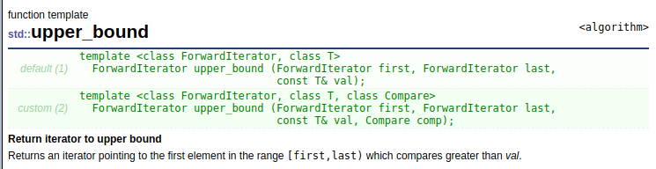
http://www.cplusplus.com/reference/algorithm/upper_bound/
With upper_bound and lower_bound, without comparator function, the array must be sorted in ascending order.
Is like to find the first insertion position.
example:
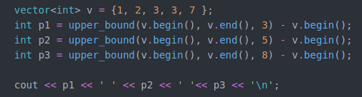

output

Is like to find the first insertion position.
The 1st insertion position of 3 is 4.
The 1st insertion position of 5 is 4.
The 1st insertion position of 8 is 5.
if the array is sorted by descending order, we must use the adequate comparator (because elements of the array are compared by > )
Is like to find the first insertion position.

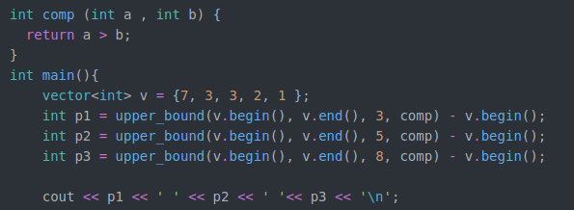

output

Instead using a personal function, you can use a built-in functions called: binary functions objects classes

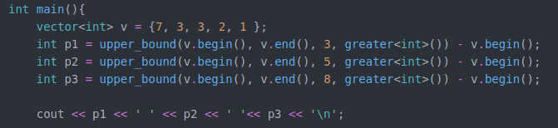
output

Is like to find the first insertion position.
The 1st insertion position of 3 is 4.
The 1st insertion position of 5 is 4.
The 1st insertion position of 8 is 5.

greater_equal<int>()
Is like to find the last insertion position.
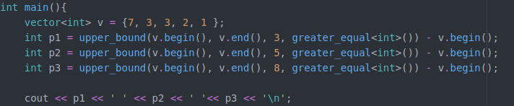

out put

The last insertion position of 3 is 1.
The last insertion position of 5 is 1.
The last insertion position of 8 is 0.

This what we need to compute the rank of the Alice’s score ins the list of scores

Whole c++ code:
/*
Successful
O(alice_count * log rank_size)
*/

#include <bits/stdc++.h>

using namespace std;

vector<int> build_rank(vector<int> scores){
vector<int> score_rank;
int scores_size = scores.size();
for (int i = 0 ; i < scores_size - 1 ; ++i)
if (scores[i] != scores[i+1]) score_rank.push_back(scores[i]);
score_rank.push_back(scores[scores_size-1]);
return score_rank;
}

vector<int> climbing_leaderboard(vector<int> scores, vector<int> alice) {
// (1): Build the rank
vector<int> score_rank = build_rank(scores);

// (2): For each alice's score compute her rank:
// By searching the last value in the rank array, which is greater or eqaul to the alice's score.
// To do that: we use:
// upper_bound function (http://www.cplusplus.com/reference/algorithm/upper_bound/)
// greater_equal<int>() binary function object class (http://www.cplusplus.com/reference/functional/greater_equal/)
// Complexity: O(alice_count * log rank_size)
vector<int> result;
int rank_size = score_rank.size();
for (auto alice_score: alice)
result.push_back(upper_bound(score_rank.begin(),score_rank.end(),alice_score, greater_equal<int>()) - score_rank.begin() + 1);

return result;
}

int main(){
int scores_count;
cin >> scores_count;

vector<int> scores(scores_count);

for (int i = 0; i < scores_count; i++)
cin >> scores[i];

int alice_count;
cin >> alice_count;

vector<int> alice(alice_count);

for (int i = 0; i < alice_count; i++)
cin >> alice[i];

vector<int> result = climbing_leaderboard(scores, alice);

for (int i = 0; i < result.size(); i++) {
cout << result[i];

if (i != result.size() - 1) {
cout << "\n";
}
}

cout << "\n";

return 0;
}


